Candidate Information Pack

HM Courts and Tribunals Service – Midlands Region

Role Title: County Court Bailiff
Band: Band E
Location: Various throughout the Midlands;
Leicester
Northampton
Derby
Nottingham
Black Country
Dudley
Birmingham (4)

Contents:

Welcome to HM Courts and Tribunals Service Midlands Region 3
Our Values in HM Courts and Tribunal Services 4
Our ways of working 5
Financial Benefits 6
Learning and Development 7
Health, Wellbeing and you! 8
Diversity and inclusion 9
Regional Overview 10
Application Process and Timeline 10
Job Description 11
How we recruit 14

Welcome to HM Courts and Tribunals Service Midlands Region

Hi
I’m Tracey Calleia and I’m the Delivery Director for the Midlands Region of HM Courts and Tribunals.
HM Courts and Tribunals Service is responsible for the administration of the Criminal, Civil and Family courts in England and Wales and non-devolved tribunals in Scotland and Northern Ireland. We believe justice is the foundation of a safe and fair society.
HMCTS are creating a justice system that works for everyone.
I’m pleased you’re interested in applying for one of our roles. This pack will provide you with details of why you should work for HMCTS, the opportunities it brings, the role description and details of how to apply.
Tracey Calleia Midlands Region Delivery Director
Thank you and good luck
Tracey

Our Values in HM Courts and Tribunal Services
We believe HMCTS is a great place to work, our people are passionate about delivering a fair justice system for all. We recognise that work life balance is important to us all.
We want to ensure your wellbeing is provided for and want to offer the opportunity to have a long, happy and rewarding career. Many of our people stay working with us for a long time.
When you join us, you’ll be joining a friendly community. We’ll give you opportunities to learn, develop and grow in confidence. We offer several benefits, some of which are outlined in here.
Whether you want a career or looking to work for an organisation that supports health and wellbeing, as well as rewarding our people, we are here to support you.

The way we work is underpinned by our core values, which bring the principles of justice to life. They sit at the heart of how we work and how we serve the public.

Our ways of working
HMCTS is embarking on its transformation journey, reforming the justice system and modernising our ways of working, making better use of digital technology.
We recognise our people are extremely important and to support you, we offer:

Annual, public and privilege leave | When you join us, you’ll receive 25 days annual leave which increases to 30 after you’ve been with us for 5 years. On top of this you’ll have 8 public holidays (in some areas of the UK you may get more) and a privilege day to celebrate the Queen’s birthday. We also offer the opportunity to buy and sell leave, in line with our flexible working policies.
Alternative and flexible working patterns | We are a family friendly employer and to support you or to help you achieve a good work life balance we can offer flexible working, where and when possible. This varies dependant on the area you’re working in and to meet business needs. You may be able to alter your start/finish times and have flexible lunches. We will also consider alternative working patterns, including job sharing, term time or part year working and partial retirement. Your working pattern will be discussed and agreed prior to you starting with us.
Family friendly leave | For new parents (or soon to be parents), we offer maternity and adoption leave. Our maternity leave policy allows you to take up to 52 weeks leave, no matter how long you’ve worked with us. You can apply for adoption leave, of up to 52 weeks, when you’ve been with us for one continuous year (as at the date of match for the adoption).  We also provide options joint parental leave and paternity leave.
Special paid or unpaid leave | There’ll be occasions when you have to deal with unforeseen circumstances or emergencies, and we may be able to offer you either paid or unpaid time off to deal with these times. This is subject to business needs and your manager will be able to provide advice on options available to you.  We are supportive of our reservists and offer time off for your training.

Financial Benefits

Pension | For some of you, retirement may seem a long way off but wherever you are in your life, when you start with us we want to help you plan. You’ll be automatically enrolled into the Civil Service Pension scheme. This means that whilst you’ll have to contribute, we will be providing an additional employer contribution.  You can find out more here: https://www.civilservicepensionscheme.org.uk/
Reward and recognition | Our reward and recognition scheme is here to recognise the exceptional contributions from our people. Awards can be made using vouchers, gifts or as part of your salary up to a maximum of £2500 per person in a financial year.  We offer a range of benefits and discounts available through our provider Edenred and have also partnered with XeXec to provide additional discounts, services and perks for our people.
Salary Advances | We recognise that you may have to pay out significant amounts of money to travel to work. For some of these circumstances we offer a salary advance to help with things like travel season tickets.
Financial Wellbeing | Sometimes you may need additional support or financial planning. You’ll have free access to the Governments “Money Advice Service” to provide impartial advice, provide tools, guides and calculators.  As a Civil Servant, you’ll also have access to a range of other support and your manager will be able to provide you with more information.
Non-Financial benefits | We may provide you with free annual sight tests.  At some of our sites we have fitness centres you can use. We also have on site food/beverage (dependent upon the location) facilities.  We provide free access to our employee assistance programme, PAM (People Asset Management) Group, who offer both mental health support as well as access to their PAM Assist life app that supports physical wellbeing. PAM Group also run regular wellbeing webinars.  We are proud to be a disability employer and can offer you a wide range of reasonable adjustments.  We have a variety of support networks available for you to join.

Learning and Development
We are passionate about learning and development and have a wide range of opportunities for you to grow your career with us.

Developing your career | In HMCTS we are passionate about recognising the skills you bring and how we develop those skills to enable you to be the best you can be.  We pride ourselves in being able to identify your talents and will provide you with access to a range of learning and development opportunities to grow your career.
Development | As a minimum we offer:  A guaranteed 5 days learning each year, whether that’s on the job training or developing new skills through Civil Service Learning.  Role specific or profession specific learning.  Targeted development programmes.  Approved volunteering.
Job opportunities | When you join us, you’ll have access to apply for other HMCTS jobs that aren’t advertised externally. You’ll also be able to apply for jobs across government.
Apprenticeships | We also provide opportunities for you to obtain a recognised vocational qualification through one of our apprenticeships, giving you the opportunity to earn, whilst you learn.
Induction | We provide all new staff an induction into HMCTS and what it means for you to work in our region.
Leadership Programmes | We offer the leadership development programmes for our leaders and provide practical learning for all our line managers.

Health, Wellbeing and you!

Employee Assistance Programme | You will have access to free, independent, confidential support services provided by the PAM (People Asset Management) Group. They offer 24-hour support, 365 days a year. You’ll get clinical and professional expert advice, covering a wide range of topics. They also have apps such as PAM Assist or PAM life, helping you to create life goals to support your wellbeing.
Low cost private healthcare | As a civil servant you’ll have access to a range of low-cost health cover from a number of different providers. Some offer cash payments whilst others, such as CS Healthcare or Benenden Health allow you to get access to professional services.
Eyesight testing | Looking after your eyes is important so we offer free eye sight testing for our VDU users.
Mental Health support | Anyone can be affected by mental health at any point. In HMCTS we recognise that and want to support you. You’ll have access to PAM Assist where you will get advice and support and you may be eligible for up to 6 sessions of counselling.  We also have mental health allies that can signpost you to the support you may need.  We recognise that it’s ok not to be ok.
Sports and leisure | You’ll be able to join the Civil Service Sports and Social Club, who offer a wide range of discounted activities for members.
Other wellbeing  Union | In the Midlands we have our People and Culture Group and they plan the staff development and wellbeing support events over the months and years to come. It’s an exciting time to join us on our journey.  When you start with us, you can choose to join a trade union. The Public and Commercial Services Union (PCS) represent people from across the civil service and government agencies, making them the UK’s largest civil service trade union.

Diversity and inclusion
We’re passionate about diversity and the opportunities having a diverse group can bring. Here in the Midlands, we’re helping to build an organisation that represents the diverse communities we serve. We are raising awareness and pro-actively tackling issues for all our minority groups.
We work with our people to give them the tools they need to fulfil their aspirations. We recognise that the public we serve are also diverse with different needs and work hard to support them.
We are proud to support disabled colleagues, offering services such as:
- Specialist equipment and software
- Making sure all our documents are accessible.
- Access to support networks

We create an inclusive environment where our people are encouraged to be themselves and we offer support to those who need it, when they need it.

RISE Network | You are welcome to join the RISE (Racial Inclusion and Striving for Equality) Network. Their mission is to give a collective voice on issues, ensuring that the voices of our minority ethnic staff are heard across HMCTS, and to play a key role in positively influencing outcomes for Black, Asian and Minority Ethnic staff across HMCTS, and the wider MoJ.
PROUD Network | Working closely with the RISE Network, PROUD (People from Diverse Racial Origins Uniting the Department) was first launched in 2001, with a view to improving the recruitment, retention and career progression of staff at all grades from diverse racial origins throughout the Ministry of Justice.  This includes, supporting Black, Asian, Minority, Ethnic staff to allow them to: unlock their potential, identify their talents and apply their skills
LGBT+ | The Spirit Network supports LGBTQI inclusion and represent LGBTQI employees working in HMCTS and the wider MOJ. The main aim of Spirit is to support LGBTQI staff to bring their whole self to work and develop their careers and provide information to staff at all grades on LGBTQI issues, thereby building LGBTQI engagement and promoting inclusivity.

.

Regional Overview

Our team has over 2,000 people in around 45 locations across the Midlands, from Boston to Shrewsbury to Chesterfield to Wellingborough.
Our buildings range from Birmingham Civil and Family Justice Centre, with around 200 people, to Warwick with less than 5 people, in a variety of different roles.

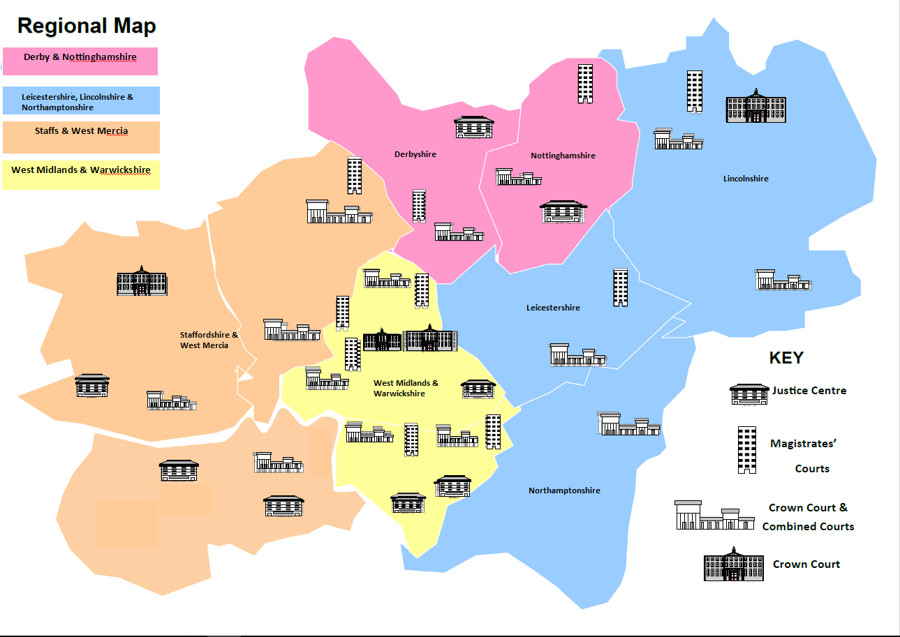

Application Process and Timeline

Success Profiles
During the various stages of the recruitment process, you will be assessed against Success Profiles.
* Please note this map is for illustrative purposes only to show the Midlands Region

Online Event
Join our online event on Wednesday 9 June 2021 at 13.15 to hear more about the role of Bailiff in HMCTS and have the opportunity to ask any questions regarding the role itself or the application process. Bailiff Managers will form part of our panel on the day.
Register in advance for the event at https://www.eventbrite.co.uk/e/hmcts-bailiff-recruitment-tickets-156629618405

Job Description

Overview | This is a uniquely satisfying yet challenging role that will require Bailiffs to deal sensitively with vulnerable individuals and to dynamically solve problems on their feet. There are comprehensive guidelines and instructions to support bailiffs in complying with the relevant legislative requirements in a safe and effective way. You will receive comprehensive training in enforcement processes and safe working practices.  Whilst the nature of the role means that bailiffs spend a proportion of the day working on their own, they are part of a wider team with management support to ensure that targets and standards are met.  Whilst you will be allocated to a specific office base, there will be a need for flexibility and to work on an ad hoc basis at other local HMCTS offices, to support delivery of exceptional customer service across the Midlands region.  Due to the nature of the work, there is no set working pattern, but bailiffs are required to work some evenings and Saturday mornings as part of your working week.
Purpose | As a Bailiff you will be required to travel to homes and businesses to:  - The enforcement of civil warrants of control. This includes peaceful entry of premises to collect sums due, or to levy and potentially seize goods to be sold at auction to settle the debt  - The enforcement of possession orders. Bailiffs will attend premises to enforce eviction orders, and the orderly transfer of property back to the rightful owner  - The service of legal documents, such as divorce petitions and non-molestation orders  - Occasionally, bailiffs may also be required to arrest individuals on committal warrants, which includes the need to attend court and transport prisoners to and from prison.  - The role also requires bailiffs to spend time on administrative duties, such as planning routes, assessing risks, completing details and accurate records of activities, and updating case files
Key Accountabilities | - Removing goods where necessary to satisfy outstanding judgments  - Obtaining possession of properties, by way of an eviction, where it has been so ordered.  - Completing related paperwork and accurately receipting monies received.  - Serving committal orders/warrants.  - Serving Court documents personally.  - Inputting data and responding to e-mails.  - Conveying prisoners to Court and attending in court when required.  - General administrative duties  - Processing of cash payments with regard to propriety and security of monies.  - Dealing with queries in person, by post and over the telephone.
Knowledge, skills and experience | 3 GCSE passes (or equivalent) grades A*-C, or NVQ Business Administration level II or experience in a similar role would be preferable. There is some computer use (inputting, e-mails, for example) so computer skills to undertake work at the level required is also essential.  The nature of the bailiff role means that candidates must possess a valid entitlement to drive unsupervised in the UK, at the point of commencement of their duties.  Successful candidates will:  •Excellent interpersonal skills, enjoy interacting with colleagues, members of the public and external stakeholders;  •Are flexible, adaptable and creative in solving problems and dealing with change;  •Are able to successfully perform a range of multi-skilled duties;  •Have a strong sense of personal ethics and integrity;  •Are able to confidently manage potentially difficult and challenging situations;  •Can demonstrate sound interpersonal, communication and relationship building skills and thrive working as part of a team;  •Have leadership potential or demonstrated leadership ability;  •Think in an objective and analytical manner;  •Are robust at enforcing UK law whilst maintaining professionalism and sensitivity.
Problem Solving and Decision Making | The post holder is required to work in a flexible way and undertake any other duties reasonably requested by line management which are commensurate with the grade and level of responsibility of this post.
Autonomy | Whilst the nature of the role means that bailiffs spend a proportion of the day working on their own, they are part of a wider team with management support to ensure that targets and standards are met.
How we will assess your application | Applications are invited through: https://www.civilservicejobs.service.gov.uk/csr/index.cgi  We will assess your application through a CV an up to 750 word personal statement using the following behaviours:  - Making effective decisions  - Managing a Quality Service  - Communicating and Influencing
Security | Successful candidates must meet the security requirements before they can be appointed. The level of security needed is security check.  People working with government assets must complete basic personnel security standard checks.

How we recruit
What are the Success Profiles?
The Success Profile Framework was introduced to attract and retain people of talent and experience from a range of sectors and all walks of life, in line with the commitment in the Civil Service Workforce Plan.
For this role you will be assessed using both the behaviours and strengths frameworks.
More information can be found here: Success Profiles - GOV.UK (www.gov.uk)
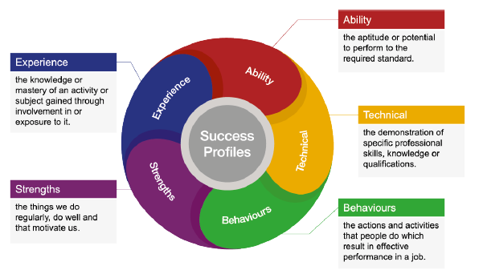
Indicative Timeline
Please note these dates are indicative and may be subject to change. Where possible, we will keep you informed of your progress.
Applications close at: TBC
We will sift your application by: TBC
Interviews will take place week commencing TBC
Sifting: We’ll use the evidence you’ve supplied in your application to assess you against the behaviours outlined in the job description.
Interview: We’ll assess both strengths and behaviours at interview.

