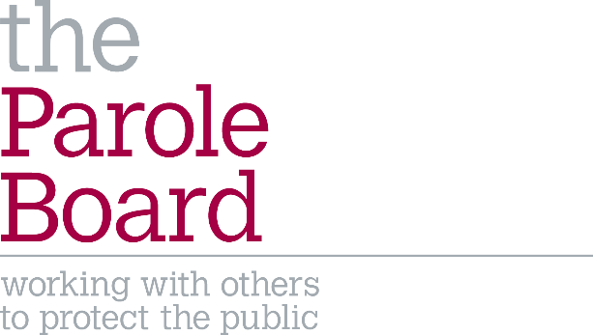
JOB DESCRIPTION: Senior People Manager

About the Parole Board:
The Parole Board is an independent court-like body that is responsible for carrying out risk assessments on prisoners to determine whether they can be safely released into the community. We do that with great care and public protection is our top priority.
All Parole Board decisions are solely focused on whether a prisoner would represent a significant risk to the public after release. Not all decisions Members make are popular, but they make these decisions fairly and objectively.
The Board is made up of about 180 members of secretariat staff based in our London Head Office and approximately 320 Members who make decisions on risk and hold hearings at prisons around the country.
The Parole Board is an executive non-departmental public body, sponsored by the Ministry of Justice. Staff who work for the Parole Board Secretariat are Public Servants and not Civil Servants.

Job Title | Senior People Manager
Department | People Hub | Team | People
Job Grade | SEO | Number of Posts | 1
Reports to | Head of People, Learning and Development (HoPLD)
Job Purpose | This role supports the HoPLD in all people related planning for the organisation including work force planning, and effective succession planning. This will sit across members and the secretariat, ensuring complex requirements are taken into consideration.  You will oversee and ensure delivery of the People related support for staff, managers and the organisation. Including reporting responsibilities and delivering against business and personal KPIs.
Scope of Responsibilities: | Activities and actions relating to:  - Policies and procedures  - Wellbeing  - Recruitment and succession  - Performance management and talent management  - People analytics and reporting
Primary Deliverables | A suite of compliant and relevant policies and procedures  A supported and trained workforce  A workforce plan  Reliable and reportable people data and analytics
Person Specification
Essential | - Demonstrable previous experience working in a people management role delivering:  - Strategic planning  - Analysing HR data and trends  - Budget and payroll  - Team management  - Policy and procedure drafting
Desirable | - CIPD Level 5 or demonstrable equivalent experience and knowledge  - Collaborative attitude

Main Duties:

Policies and training
- Oversight of all people policies and procedure ensuring compliance and accuracy.
- Liaise with the Head of Learning and Development to ensure members, managers and staff are informed of and trained in relevant policies and procedures.
- Support and provide people training to managers across all grades in the Parole Board where required.
- Ensure staff and member wellbeing, working closely with the HoPLD.

Reporting and audit
- Responsibility for accurate payroll, bonus, pension and headcount actioning and reporting.
- Responsibility for the collection, maintenance and analysis of people data and trends to draft regular reports and recommendations for the HoPLD.
- With the Head of Learning and Development, undertake a skills audit for the secretariat and membership.
- Create and maintain contingency and information assurance plans.

Recruitment
- With the HoPLD create a workforce plan identifying talent and succession.
- Strategically guide on staff recruitment across hubs, reviewing business cases, with suggested planning and amendments.
- Provide guidance and support to the HoPLD for strategic member recruitment.
- Oversee the timely delivery of reappointments.

Oversight
- Oversight of the Performance Management Review system, ensuring compliance with budget restrictions and policy.
- Organisation and delivery of people surveys and accreditations.
- Oversight of day-to-day people guidance.
- Responsibility for pension compliance.

Management and leadership
- Manage and support a team of 4, with two direct line reports.
- Co-Chair the EIR Staff Committee.
- Promote organisational culture of transparency, fairness and independence.
- Actively contribute to and deliver against the PB and functional hub’s business plan and organisational priorities.
- Represent the organisation at cross-departmental meetings, and liaise with the unions to ensure consultation on relevant changes that may affect staff terms and conditions.
- Build and maintain collaborative working relationships with external stakeholders to ensure PBs People needs are fully supported.
- Undertake these responsibilities in line with current legislation, local and national policies, and the key documents.
- Other tasks as assigned from time to time by the HoPLD.

