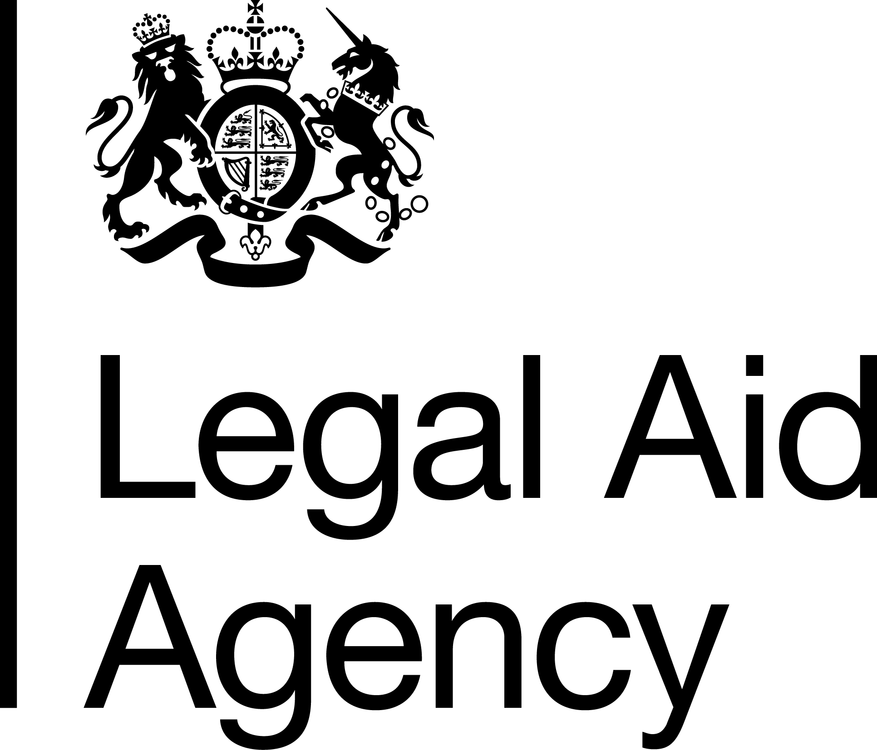Health and Safety Adviser.

Job Description

**Job Title**: Health and Safety Adviser

**Grade**: C

**Location**: Based in any LAA office or home based.

**Working Pattern**: This post supports smarter working – this includes colleagues who work flexibly, part-time or as part of a job shares etc.

**Department**: Corporate Centre

**Reports to**: Health and Safety Manager.

Organisational context

We are an executive agency of the Ministry of Justice (MoJ). We provide civil and criminal legal aid and advice in England and Wales to help people deal with their legal problems.

Our people are at the heart of achieving excellence. Employing around 1,450 colleagues in offices in towns and cities across England and Wales. We feel proud to have some of the best [People Survey results](https://intranet.justice.gov.uk/guidance/statistics-and-survey-results/people-survey-2016/) in the Civil Service.

The Corporate Centre helps shape and enable the priorities of the Chief Executive, Executive Leadership Team and Executive Committees to be delivered.

The role of Health and Safety Adviser is a new post and sits within the Legal Aid Agency’s Corporate Centre Assurance Team reporting to the Health and Safety Manager. The team provides advice and assurance on the Agency’s strategic management of risk, information security, physical security, business continuity planning and health & safety. The Health and Safety Adviser will focus on the operational support across all our directorates.

Our offices cover 16 sites in England and Wales, ranging from single occupancy to shared office space alongside other government departments and private companies. Our people are primarily office based; however, as a business we are increasingly promoting flexible working practices that allow everyone the opportunity to work from regional hubs and home. We also employ contract managers, solicitors and advocates, who routinely work alone and drive as part of their role, while our main postal hub and records center highlight the importance of safe manual handling and work at heights.

The LAA fully supports smart and flexible working. Members of the Corporate Centre and the Assurance Team are based in multiple locations across England and Wales. Travel and overnight stays will be required on occasion.

Job summary

* *Are you passionate about making a difference to the health, safety and wellbeing of staff?*
* *Do you enjoy collaborating with colleagues across varying roles to make things happen?*
* *Are you ready to achieve your full potential by being fair, proud and supportive of others?*
* *Do you enjoy a fast paced decision making role?*

Key duties and responsibilities:

* To provide advice to the Legal Aid Agency (LAA) to ensure it meets the requirements of Health and Safety legislation and support the delivery of the corporate Health and Safety strategy and arrangements.
* To advise managers on the implementation and delivery of the corporate Health and Safety Policy, procedures and the LAA Health and Safety Delivery Plan, while utilising the support of Site Leads and network of regional H&S representatives.
* The post holder will develop and maintain key contacts across government departments H&S teams to provide consistent and balanced advice relevant to LAA offices promoting a positive health and safety culture.
* The post holder will be required to complete investigations, audits and deliver training related to all aspects of health, safety and wellbeing.
* The post holder will be required to work with colleagues in security, facilities management, agency partners and communications to support cross MOJ agendas.
* Deliver reports, information, data and recommendations in all aspects of health and safety operational delivery that help drive improvements and engagement with the ambitions of our assurance team.
* Work collaboratively within the corporate center assurance team learning new skills and shared expertise in business continuity and physical security.
* All roles involve providing a degree administrative support.
* The role includes travelling to inspect and delivery support across all LAA offices with occasional overnight stays dependent on base location.
* Promote and maintain practices which are free from discrimination, support equality of opportunity and reflect the LAA diversity and equality policy.

Person specification

**Essential criteria**

* Minimum qualification: Minimum of NEBOSH or NCRQ Certificate Level 3 which would qualify you to membership of IOSH as a TechIOSH.
* Evidence of current and up to date Health and Safety CPD.
* Ability to efficiently plan, organise time and workload to ensure delivery of plans.
* Ability to communicate with colleagues at all levels.
* Ability to interact and engage colleagues – beyond your own team - to achieve shared goals.
* Ability to work autonomously, identify and mitigate risks and spot opportunities to improve the health, safety and wellbeing of staff.
* Knowledge and understanding of health, safety and wellbeing strategies to provide competent and trusted advice.
* A personal commitment to professional development, a desire to work towards National and Vocational Qualification (NVQ/SVQ) Level 5 Occupational Health and Safety Practice or to a level such as that would satisfy the criteria for Graduate Membership of IOSH.

**Desirable criteria**

* Experience in fire safety, water hygiene and asbestos risk management.
* Ability to write engaging copy with some experience of writing for impact e.g. policy, procedures and risk assessments.
* Experience of a variety of digital and remote working tools.
* Experience of facilitation of workshops, design and delivery of training and planning and delivering events.
* Knowledge and/or experience of how to use quantitative and qualitative data to inform future plans, including ISO standards in H&S.

Assessment approach

Candidates will be invited to a short interview and complete an exercise in responding to incident reports and requests for advice or guidance.

In the application we will assess you against the following behaviours:

* Communicating and Influencing
* Managing a Quality Service
* Making Effective Decisions

In the interview we will assess you against strengths that are relevant to the role and the following behaviours:

* Delivering at Pace
* Seeing the Bigger Picture
* Working Together

Our LAA commitment

The LAA is committed to diversity and inclusion and we positively promote [flexible working](https://intranet.justice.gov.uk/guidance/hr/support-and-wellbeing/flexible-working/), including job shares.

We will consider all applications on merit regardless of age, disability, gender identity, sexual orientation, socio-economic background, religion, ethnicity, preferred working pattern and except for exceptional circumstances your working location.

As a Disability Confident organisation, we will offer a guaranteed interview to candidates with a disability who meet the essential criteria for this role. Under the Equality Act 2010 a disability is defined as a physical or mental impairment which has a substantial and long-term adverse effect on your ability to carry out normal day-to-day activities which has lasted, or is expected to last, at least 12 months.

If you are responding to a role within the Legal Aid Agency and would like to be considered under the guaranteed interview please ensure that you attach the Guaranteed Interview Form when you return your application. You can use the same form to let the recruiting manager know of any reasonable adjustments you may require during the sift or later selection processes.

