Candidate Information Pack

HM Courts and Tribunals Service – Midlands Region

Role Title: Administrative Officer
Band: Band E
Location: Birmingham

Welcome to HM Courts and Tribunals Service Midlands Region

Tracey Calleia Midlands Region Delivery Director

Hi
I’m Tracey Calleia and I’m the Delivery Director for the Midlands Region of HM Courts and Tribunals.
HM Courts and Tribunals Service is responsible for the administration of the Criminal, Civil and Family courts in England and Wales and non-devolved tribunals in Scotland and Northern Ireland. We believe justice is the foundation of a safe and fair society.
HMCTS are creating a justice system that works for everyone.
I’m pleased you’re interested in applying for one of our roles. This pack will provide you with details of why you should work for HMCTS, the opportunities it brings, the role description and details of how to apply.
Thank you and good luck
Tracey

Contents:

Our Values in HM Courts and Tribunal Services 4
Our ways of working 5
Financial benefits 6
Learning and Development 7
Health, Wellbeing and you! 8
Diversity and inclusion 9
Regional Overview ……………………………………………………………………………………………… 10
Application Process and Timeline 11
Job Description 12

Our Values in HM Courts and Tribunal Services
We believe HMCTS is a great place to work, our people are passionate about delivering a fair justice system for all. We recognise that work life balance is important to us all.
We want to ensure your wellbeing is provided for and want to offer the opportunity to have a long, happy and rewarding career. Many of our people stay working with us for a long time.
When you join us, you’ll be joining a friendly community. We’ll give you opportunities to learn, develop and grow in confidence. We offer several benefits, some of which are outlined in here.
Whether you want a career or looking to work for an organisation that supports health and wellbeing, as well as rewarding our people, we are here to support you.

The way we work is underpinned by our core values, which bring the principles of justice to life. They sit at the heart of how we work and how we serve the public.

Our ways of working
HMCTS is embarking on its transformation journey, reforming the justice system and modernising our ways of working, making better use of digital technology.
We recognise our people are extremely important and to support you, we offer:

Annual, public and privilege leave | When you join us, you’ll receive 25 days annual leave which increases to 30 after you’ve been with us for 5 years. On top of this you’ll have 8 public holidays (in some areas of the UK you may get more) and a privilege day to celebrate the Queen’s birthday. We also offer the opportunity to buy and sell leave, in line with our flexible working policies.
Alternative and flexible working patterns | We are a family friendly employer and to support you or to help you achieve a good work life balance we can offer flexible working, where and when possible. This varies dependant on the area you’re working in and to meet business needs. You may be able to alter your start/finish times and have flexible lunches. We will also consider alternative working patterns, including job sharing, term time or part year working and partial retirement. Your working pattern will be discussed and agreed prior to you starting with us.
Family friendly leave | For new parents (or soon to be parents), we offer maternity and adoption leave. Our maternity leave policy allows you to take up to 52 weeks leave, no matter how long you’ve worked with us. You can apply for adoption leave, of up to 52 weeks, when you’ve been with us for one continuous year (as at the date of match for the adoption).  We also provide options joint parental leave and paternity leave.
Special paid or unpaid leave | There’ll be occasions when you have to deal with unforeseen circumstances or emergencies, and we may be able to offer you either paid or unpaid time off to deal with these times. This is subject to business needs and your manager will be able to provide advice on options available to you.  We are supportive of our reservists and offer time off for your training.

Financial Benefits

Pension | For some of you, retirement may seem a long way off but wherever you are in your life, when you start with us we want to help you plan. You’ll be automatically enrolled into the Civil Service Pension scheme. This means that whilst you’ll have to contribute, we will be providing an additional employer contribution.  You can find out more here: https://www.civilservicepensionscheme.org.uk/
Reward and recognition | Our reward and recognition scheme is here to recognise the exceptional contributions from our people. Awards can be made using vouchers, gifts or as part of your salary up to a maximum of £2500 per person in a financial year.  We offer a range of benefits and discounts available through our provider Edenred and have also partnered with XeXec to provide additional discounts, services and perks for our people.
Salary Advances | We recognise that you may have to pay out significant amounts of money to travel to work. For some of these circumstances we offer a salary advance to help with things like travel season tickets.
Financial Wellbeing | Sometimes you may need additional support or financial planning. You’ll have free access to the Governments “Money Advice Service” to provide impartial advice, provide tools, guides and calculators.  As a Civil Servant, you’ll also have access to a range of other support and your manager will be able to provide you with more information.
Non Financial benefits | We may provide you with free annual sight tests.  At some of our sites we have fitness centres you can use. We also have on site food/beverage (dependant upon the location) facilities.  We provide free access to our employee assistance programme, PAM (People Asset Management) Group, who offer both mental health support as well as access to their PAM Assist life app that supports physical wellbeing. PAM Group also run regular wellbeing webinars.  We are proud to be a disability employer and can offer you a wide range of reasonable adjustments.  We have a variety of support networks available for you to join.

Learning and Development
We are passionate about learning and development and have a wide range of opportunities for you to grow your career with us.

Developing your career | In HMCTS we are passionate about recognising the skills you bring and how we develop those skills to enable you to be the best you can be.  We pride ourselves in being able to identify your talents and will provide you with access to a range of learning and development opportunities to grow your career.
Development | As a minimum we offer:  A guaranteed 5 days learning each year, whether that’s on the job training or developing new skills through Civil Service Learning.  Role specific or profession specific learning.  Targeted development programmes.  Approved volunteering.
Job opportunities | When you join us, you’ll have access to apply for other HMCTS jobs that aren’t advertised externally. You’ll also be able to apply for jobs across government.
Apprenticeships | We also provide opportunities for you to obtain a recognised vocational qualification through one of our apprenticeships, giving you the opportunity to earn, whilst you learn.
Induction | We provide all new staff an induction into HMCTS and what it means for you to work in our region.
Leadership Programmes | We offer the iTransform programme for our leaders and provide practical learning for all our line managers.

Health, Wellbeing and you!

Employee Assistance Programme | You will have access to free, independent, confidential support services provided by the PAM (People Asset Management) Group. They offer 24-hour support, 365 days a year. You’ll get clinical and professional expert advice, covering a wide range of topics. They also have apps such as PAM Assist or PAM life, helping you to create life goals to support your wellbeing.
Low cost private healthcare | As a civil servant you’ll have access to a range of low-cost health cover from a number of different providers. Some offer cash payments whilst others, such as CS Healthcare or Benenden Health allow you to get access to professional services.
Eyesight testing | Looking after your eyes is important so we offer free eye sight testing for our VDU users.
Mental Health support | Anyone can be affected by mental health at any point. In HMCTS we recognise that and want to support you. You’ll have access to PAM Assist where you will get advice and support and you may be eligible for up to 6 sessions of counselling.  We also have mental health allies that can signpost you to the support you may need.  We recognise that it’s ok not to be ok.
Sports and leisure | You’ll be able to join the Civil Service Sports and Social Club, who offer a wide range of discounted activities for members.
Other wellbeing  Union | In the Midlands we have our People and Culture Group and they plan the staff development and wellbeing support events over the months and years to come. It’s an exciting time to join us on our journey.  When you start with us, you can choose to join a trade union. The Public and Commercial Services Union (PCS) represent people from across the civil service and government agencies, making them the UK’s largest civil service trade union.

Diversity and inclusion
We’re passionate about diversity and the opportunities having a diverse group can bring. Here in the Midlands, we’re helping to build an organisation that represents the diverse communities we serve. We are raising awareness and pro-actively tackling issues for all our minority groups.
We work with our people to give them the tools they need to fulfil their aspirations. We recognise that the public we serve are also diverse with different needs and work hard to support them.
We are proud to support disabled colleagues, offering services such as:
- Specialist equipment and software
- Making sure all our documents are accessible.
- Access to support networks
We create an inclusive environment where our people are encouraged to be themselves and we offer support to those who need it, when they need it.
RISE Network
You are welcome to join the RISE (Racial Inclusion and Striving for Equality) Network. Their mission is to give a collective voice on issues, ensuring that the voices of our minority ethnic staff are heard across HMCTS, and to play a key role in positively influencing outcomes for Black, Asian and Minority Ethnic staff across HMCTS, and the wider MoJ.
PROUD Network
Working closely with the RISE Network, PROUD (People from Diverse Racial Origins Uniting the Department) was first launched in 2001, with a view to improving the recruitment, retention and career progression of staff at all grades from diverse racial origins throughout the Ministry of Justice.
This includes, supporting Black, Asian, Minority, Ethnic staff to allow them to: unlock their potential, identify their talents and apply their skills.
LGBT+
The Spirit Network supports LGBTQI inclusion and represent LGBTQI employees working in HMCTS and the wider MOJ. The main aim of Spirit is to support LGBTQI staff to bring their whole self to work and develop their careers and provide information to staff at all grades on LGBTQI issues, thereby building LGBTQI engagement and promoting inclusivity.

Regional Overview

Our team has over 2,000 people in around 45 locations across the Midlands, from Boston to Shrewsbury, from Chesterfield to Wellingborough.
Our buildings range from Birmingham Civil and Family Justice Centre, with around 200 people, to Warwick with less than 5 people, in a variety of different roles.

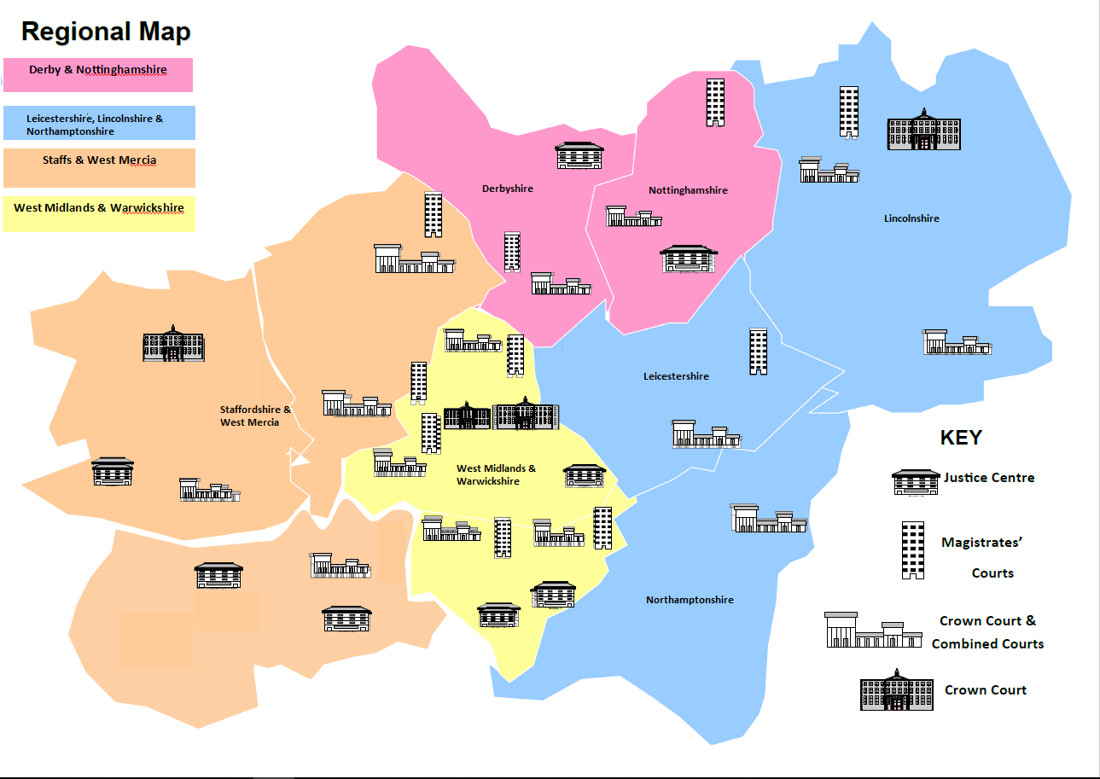

Application Process and Timeline

Success Profiles
During the various stages of the recruitment process, you will be assessed against Success Profiles.
What are the Success Profiles?
The Success Profile Framework was introduced to attract and retain people of talent and experience from a range of sectors and all walks of life, in line with the commitment in the Civil Service Workforce Plan.
For this role you will be assessed using both the behaviours and strengths frameworks.
More information can be found here: Success Profiles - GOV.UK (www.gov.uk)
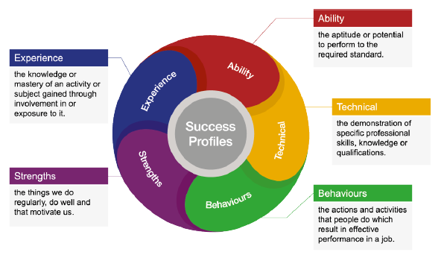
Indicative Timeline
Please note these dates are indicative and may be subject to change. Where possible, we will keep you informed of your progress.
Applications close at: Wednesday 14 April 2021
We will sift your application by 20 April 2021
Interviews will take place by: 21 May 2021
Sifting: We’ll use the evidence you’ve supplied in your application to assess you against the Managing a Quality Service behaviour outlined in the job description.
Interview: We’ll assess both strengths and behaviours at interview.

Job Description

Overview | HM Courts and Tribunals are going through a significant change journey. Strong leadership is critical to enable our people to go through reform
Purpose | Our purpose is to deliver justice in a fair, open and transparent way. The Delivery Manager is responsible for:  Delivering a consistent and customer focussed service  ensuring we have the resources we need to deliver this service  monitoring and delivering key cluster performance objectives.
Administration | - Preparing papers and files for court, tribunals, hearings and meetings.  - Producing court/tribunal documents.  - General photocopying and filing.  - Creating and updating records on in-house computer system and data input.  - Post opening and dispatch.  - Booking, preparing and organising meeting rooms, supporting training courses and other group activities.  - Preparing meeting agenda, joining instructions, handouts etc.
Drafting | - Standard letters and correspondence, minutes, notes, reports, submissions etc, according to guidelines and instructions.
Operations | - Clerking civil and family courts, tribunals and hearings, ensuring papers and materials are available and up to date  - Assisting court users, supporting listing and rota management, checking files  - Contacting relevant parties, scheduling, serving court documents, executing a range of warrants, collecting fines and fees etc, including the use of chip and pin  - Handling counter (face to face), written and telephone enquiries.  - To work as a team to ensure TIB (Team Information Board) meetings are relevant, timely and productive  - To work as a team to problem solve, to assess the impact of new SOPS, to contribute to small projects  - To undertake ad hoc roles within the band such as Jury Bailiff Officer, L+D Co-ordinator, H+S roles
Processing casework | - Including standard documentation and information, court orders, claims, fines and fees, legal aid  - Resulting courts accurately, interpreting accurately the information required on a court file  - To work to workload targets in terms of throughput and accuracy
Checking and verifying | - Documents, records, accounts, claims and returns for approval, results, statistics, plans etc. against criteria, regulations or procedures.  - Ensuring compliance and administration documentation meet quality standards.  - Role holders may be required to cross check and validate work completed by colleagues.
Collecting and assembling information | - For returns, results, accounts, statements, warrants, statistical analysis, reports etc.  - Work may require interpretation of source materials, preparation of bundles, chasing.  - Role holders will need to modify and adjust information and make decisions to allow work to be completed.  - Role holders will need to collect and assemble information to prepare for and run the daily TIB meeting, as required
Undertaking calculations | - Produce basic statistical analysis reports and where required, process financial information.  - Checking the work of others, updating records, assessing the value of goods and/or property, reconciling accounts, preparing invoices, information gathering and running straightforward reports.  - Spending limited sums of money on behalf of an office or unit.  - Calculate the anticipated numbers of Jurors to be called and manage the numbers to be as efficient as possible
Communicating with the public, the judiciary, other court and tribunal users and representatives of other agencies and Organisations | - Communicate and work with the Judiciary, Magistracy, the Cluster Managers, Court staff, and other internal and external stakeholders, suppliers and customers to collect information, check facts, communicate or enforce judicial decisions, give advice on the completion of forms or court procedures etc and provide excellent customer service.  - To deliver a helpful, prompt, polite and “right first time” service to our internal and external customers
How we will assess your application | Applications are invited through: https://www.civilservicejobs.service.gov.uk/csr/index.cgi  We will assess your application using the following behaviours:  - Communicating and Influencing  - Changing and Improving  - Managing a Quality Service
Security | Successful candidates must meet the security requirements before they can be appointed. The level of security needed is security check.  People working with government assets must complete basic personnel security standard checks.

